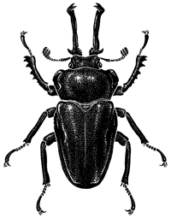

**Entomological Society of Queensland**

2024 Small Grants Scheme Pro forma

Please complete the following sections, sign at the end, and send/email to the ESQ Secretary (secretary@esq.org.au) by the due date of 30 April 2024. Attach additional pages if necessary, but please stay within boxes as much as possible. The outcome of the selection process will be

announced by 30th June 2024. Funds will be available to the successful applicant in July.

1. Name of applicant (one name per application) and membership type (i.e., general/student/joint)
2. Project proposal: Please include a **TITLE** and respond to: What are the objectives and/or hypotheses of your project? Is it a stand-alone project or linked to a larger project? Does your project have a close link with Queensland? What methodologies or approaches will you use to complete the project?
3. Proposed budget ($2,000 maximum). Please itemise how funds will be spent, including airfares, accommodation, collecting equipment, or any other expenses that you will need to complete the project. Funding provided to the successful applicant must only be used for expenses related directly to the project proposal. The ESQ takes no responsibility or liability for actions or consequences resulting from the use of funds provided under the SGS scheme.
4. Timeline. Please provide a detailed timeline of when you propose to undertake project- related activities.
5. Please state whether you wish your project to be kept on file for 2023 in the event it is unsuccessful.

Yes  No 

1. Do you anticipate this work may be suitable for submission to the Society’s journal, *The Australian Entomologist*?

Yes No 

1. Would you be prepared to present the outcomes of your research project to an ESQ General Meeting, if the opportunity arises?

Yes  No 

Signature of applicant:

Date:

We thank you for your submission!