**Entomological Society of Queensland**

$500 Student Award 2025

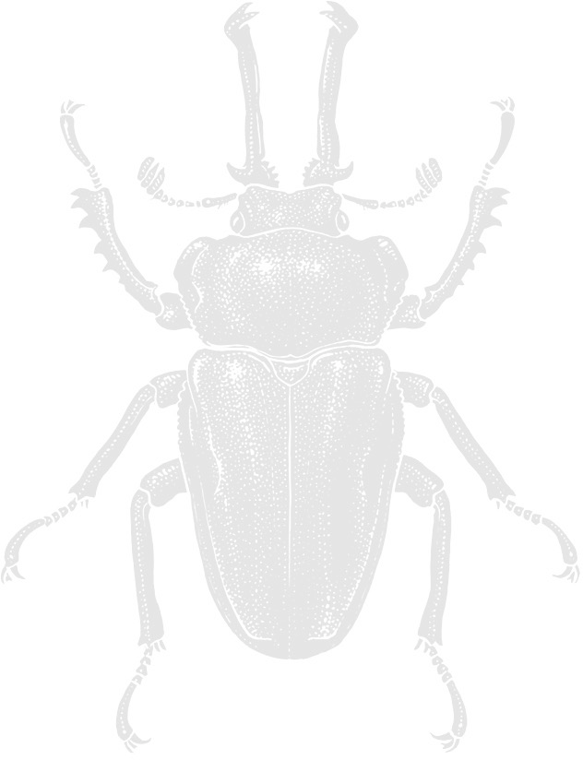

This is an award by the Society to encourage entomological research. Honours, Diploma and 4th year Degree students who received their qualification from any Queensland tertiary education institution in 2023 OR 2024 may submit their entomology-based thesis or report for consideration.

Entrants need not be Society members.

Entries are judged by a panel of three entomologists appointed by the President of the Society. The winner will be announced at the May General Meeting and is then invited to present a summary of their research at the June Notes and Exhibits meeting of the Society.

Please note, a hard copy of your thesis/report does not need to be submitted, and the submission of a PDF version is highly encouraged. This should be emailed together with a signed copy of the completed entry form to the secretary at: [secretary@esq.org.au](mailto:secretary@esq.org.au)

Closing date for submissions is Friday, April 4, 2025.

**2025 Student Award Entry Form**

Also available at <http://www.esq.org.au/awards.html>

Name:

Title of thesis or report:

Degree: Supervisor:

Date of Examiners report or grading:

Return address for thesis/report (if

applicable):

Signature: Date:

Send in thesis/report with a signed and completed entry form to: [secretary@esq.org.au](mailto:secretary@esq.org.au) OR President, The Entomological Society of Queensland, PO Box 537, Indooroopilly Qld 4068 Australia

*Entomological Society of Queensland*